**2018-2019 JPSS Proving Ground Risk Reduction Quarterly Reporting**

2018-2019 Project Information

**Principal Investigator:** Kimberly Hyde

**Team Members:** Colleen Mouw, Ryan Morse

**Organization:** Northeast Fisheries Science Center; University of Rhode Island

**Project Title**: Optimization of phytoplankton functional type algorithms for VIIRS ocean color data in the Northeast U.S. Continental Shelf Ecosystem

2018-2019 Project Summary

*Elements include project objectives over the entire period of performance. This section should be kept brief to half of one page or less. This may include a bulleted summary. This should not change from quarter to quarter during the performance year.*

This project aims to optimize remote sensing phytoplankton functional type/size class (PFT/PSC) algorithms for the Northeast U.S. Continental Shelf for applications in fisheries management and ecosystem modeling. We will be collecting *in situ* optical and pigment data on six Ecosystem Monitoring cruises operated by the Northeast Fisheries Science Center. All available *in situ* data will then be used to validate the ocean color data (e.g. RRS and IOP products) from VIIRS and other sensors and evaluate several abundance and absorption based PFT/PSC algorithms.

Reporting Period

*Mark table, below, with an “x” corresponding to the quarter submitted*

|  |  |  |  |
| --- | --- | --- | --- |
| *CY2018 Q3*  *Period of Performance: 7/18 to 10/18* | *CY 2019 Q4: 10/1/18 to 12/31/18*  *Due: January 7,2019* | *CY 2019 Q1: 1/1/19 to 3/31/19*  *Due: April 5,2019* | *CY 2019 Q2: 4/1/18 to 16/30/19*  *Due: July 5,2019* |
| Submitted 9/26/2018 | Submitted 2/2019 | Submitted 3/28/2018 |  |

Quarterly Dashboard



|  |  |  |  |  |
| --- | --- | --- | --- | --- |
|  | Green (Controlled) | Yellow(Caution) | Red(Critical) | Variance Summary *(Provide explanations as needed. More detail may be included in issues and risks sections as needed.)* |
| **Scope** |  |  |  |  |
| **Budget** |  |  |  | A portion of year 1 funds were not properly obligated in FY’18 (see below for more details). |
| **Schedule** |  |  |  |  |

**Legend**

|  |  |  |  |  |  |
| --- | --- | --- | --- | --- | --- |
|  | *On Target* |  | *Deviation from plan which can be recovered* |  | *JPSS Program Science Attention needed.* |

|  |
| --- |
| Quarterly Accomplishments |

**Accomplishments during this Reporting Period**

1. **Summary of Accomplishments** *(This is a high level summary of quarterly activities. This paragraph should be kept brief to half of one page or less.)*

No field sampling occurred during CY 2019 Q1. Laboratory analysis of chlorophyll, colored dissolved organic matter (cdom), and particulate absorption being conducted at URI are 100% complete for cruise 1 and 50% complete for cruise 2. Chlorophyll (NEFSC) and nutrient analyses (University of Maine) are 100% complete for both cruises and HPLC pigment samples are currently being processed at the University of Maryland (data are expected in early April). We have been compiling and inquiring about additional data including CTD (NEFSC), radiometry (NESDIS), particulate absorption (NESDIS), and phytoplankton imagery (WHOI) to add to our project database. Satellite datasets from multiple sensors are up-to-date and we are developing methods to generate cf-compliant netcdf files for distribution on a NEFSC ERRDAP server. Kyle Turner, a URI student in Dr. Mouw’s laboratory, has reviewed several published PFT/PSC algorithms and is testing the algorithms with the *in situ* database.

1. **Milestones Progress** *(Provide details of the progress of each activity or milestone for this quarter as relevant. Quarterly Reports should reflect only current quarter.)*

* Laboratory Analyses 1 – URI portion is 100% Complete (On Time)
* Data Compilation (Continuous) – 60% Complete (On Time)
* Satellite Data Processing (Continuous) – 90% Complete (On Time)
* Laboratory Analyses 2 – URI portion is 50% Complete (On Time)
* Satellite Analysis (satellite-ship data match-ups) – (On Time)
* Compilation of phytoplankton imagery data – In progress (Slight delay)
* Review of published PFT/PSC algorithms – 80% Complete (On Time)

**Plans for the next Reporting Period:**

* Continue laboratory analyses
* Field Sampling 3 – Scheduled for May 22 to June 6th, 2019
* Continue data compilation for available datasets and cruises
* Complete review of published PFT/PSC algorithms
* Begin algorithm optimization for the NE Shelf and apply best performing algorithms to imagery

**Additional Information** *(This include the following, as relevant. If particular elements are not relevant to quarterly activities, write N/A/)*

1. **User engagement:** *(In addition to PGRR meetings, this includes collaboration and support for other stakeholders such as upper level management or other agencies such as FEMA. This may include a specific event like a large fire or hurricane or a field experiment, for example.)*

We created two opportunities for summer internships through the National Centers for Coastal Science internship program and are still waiting to hear if any students matched with our positions.

<https://coastalscience.noaa.gov/internships/phytoplankton-composition-and-optics-of-the-northeast-shelf/>

1. **Conference/workshop participation:** *(Conference Name, dates, materials presented)*

None this quarter

1. **Project publicity:** *(news journals/articles etc.)*

None this quarter



Quarterly Pictures and Graphics

**\*\*\* The figures shown below are preliminary results and should only be used for internal review of the project progress. \*\*\***

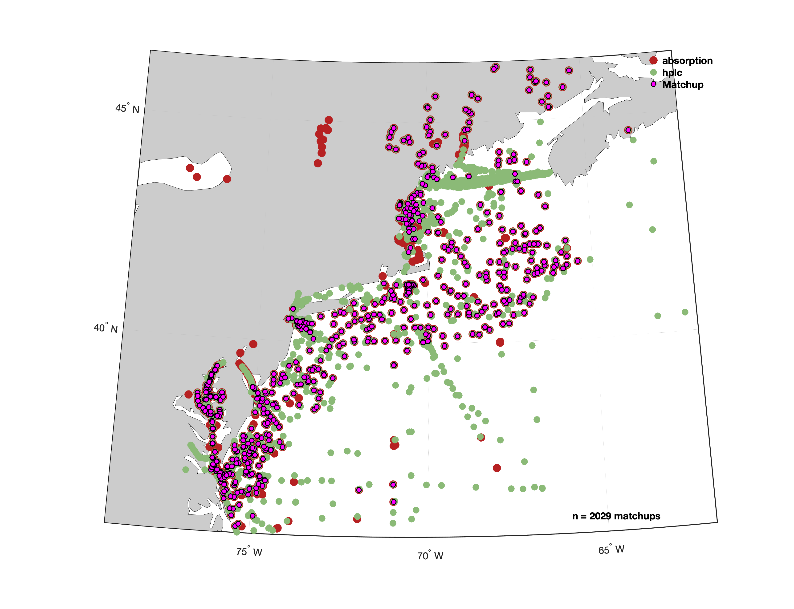

Figure 1 *In situ* data compiled from NASA's SeaBASS database that were used for the preliminary review of PFT/PSC algorithms on the Northeast Shelf. PRELIMINARY RESULTS – FOR INTERNAL USE ONLY.

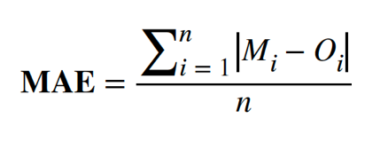

Figure 2 The percent microplankton compared to total chlorophyll *a* (black line – top figure) derived from pigment analysis of HPLC measurement collected on the Northeast Shelf compared to the Hirata et al. (2011) model (the red dashed line) and the mean absolute error (MAE), which is the sum of the differences between the model and observed data divided by the number of data points (bottom figure). This analysis indicates the need for algorithm optimization for the northeast shelf region. PRELIMINARY RESULTS – FOR INTERNAL USE ONLY.



Figure 3 The derived phytoplankton absorption for large and small+medium phytoplankton populations compared to the Devred et al. (2006 & 2011) models. PRELIMINARY RESULTS – FOR INTERNAL USE ONLY.

2018-2019 Annual Milestones with Quarterly Status Updates

*2018-2019 plan, schedule and milestones should build upon project proposals and allocated budget. This plan serves as a project management tool allowing PI’s to track and meet goals. Tasks are activities that need to be accomplished within a defined period of time. Tasks are broken down into milestones with defined start and end dates. The level of granularity is defined by individual PI. This table should be used for future quarterly reports.*

|  |  |  |  |
| --- | --- | --- | --- |
| **Milestone** | **Planned Completion Date**  *(should be part of annual plan and should not change from quarter to quarter)* | **Actual Completion** | **Status** *(not started, on track, delayed, completed …)* |
| Task 1: Field Sampling & Sample Analyses | | | |
| Field Sampling 1 | 8/31/2018 | 8/31/2018 | Completed |
| Field Data Analysis 1 (URI) | February 2019 | February 2019 | Completed |
| Field Sampling 2 | 11/14/2018 | 11/14/2018 | Completed |
| Field Data Analysis 2 (URI) | May 2019 |  | On Track |
| Field Sampling 3 | June 2019 |  | Not Started |
| Field Data Analysis 3 (URI) | January 2020 |  | Not Started |
| Field Sampling 4 | August 2019 |  | Not Started |
| Field Data Analysis 4 (URI) | March 2020 |  | Not Started |
| Field Sampling 5 | November 2019 |  | Not Started |
| Field Data Analysis 5 (URI) | June 2020 |  | Not Started |
| Field Sampling 6 | February 2020 |  | Not Started |
| Field Data Analysis 6 (URI) | October 2020 |  | Not Started |
|  |  |  |  |
| Task 2: Data Compilation & Analysis | | | |
| Data compilation | October 2020 |  | On Track |
| Satellite data processing | Continuous |  | On Track |
| Preliminary data analysis/validation | January 2020 |  | On Track |
|  |  |  |  |
| Task 3: Algorithm optimization | | | |
| Algorithm validation & optimization | May 2021 |  | Started |
| Time series analysis | May 2021 |  | Not Started |
| Modeling efforts | January 2021 |  | Not Started |
| Publication writing | June 2021 |  | Not Started |

*Add rows as needed for all annual tasks and milestones. New milestones which may arise should be added at the end of the table as needed.*

|  |
| --- |
| Issues and Risks |

##### *This section should include no more than five or issues. Please separate risks from issues. Risks are the bad things that might happen. Dependencies on other projects and resources are considered risks. Issues have already occurred. High impact variances from Quarterly Dashboard can be addressed here as needed.*

##### Risk or Issue: *(State risk or issue and impact.)*

##### Issue – Due to communications issues between the PGRR program office and NEFSC, we were unaware that the year one funds received in June 2018 needed to be spent or obligated during FY’18. The result of this error was that we were not able to fund Dr. Morse for 3 months during year 1 of the project.

1. Risk – The staff from NESDIS who collect the in-water radiometry and particulate absorption samples are unable to participate in the May 2019 cruise due to other obligations.

##### Risk – Changes in the availability of the NOAA ships and weather could cancel or reduce the sampling plan of the Ecosystem Monitoring cruises.

##### Risk – Delays in receiving complementary historical and coincident data from project partners NESDIS and WHOI.

##### Mitigation Plan or Course Correction: *(This includes options and actions to reduce risks/threats to project objectives. For issues, this includes plans to address impacts.)*

##### Mitigation Plan – We have spoken with Arron Layns and the PGRR program office has agreed to give us additional funds in year 3 of the project to make up for the lost funds in year 1. Dr. Morse’s work will be pushed back by approximately 6 months and will start on the project in July 2019.

1. Mitigation Plan – Dr. Mouw’s staff will use URI’s equipment to measure in-water radiometry and collect the particle absorption samples. NEFSC will purchase the additional supplies needed to collect the absorption samples and NESDIS has agreed to process the samples in their laboratory, eliminating the need to hire additional staff at URI.

##### Mitigation Plan – If an Ecosystem Monitoring cruise is canceled, we can try to piggy-back on another NOAA/NEFSC cruise if one is available.

##### Mitigation Plan – We are in contact with both NESDIS and WHOI regarding the status of their data. NESDIS is currently updating their *in situ* database and hope to add historical EcoMon cruise related data this spring/summer. At WHOI, they have prioritized the August and November 2018 EcoMon cruises for quality control verification and geolocation. Historical verified IFCB data collected in the Northeast will be shared as it becomes available.

##### Status: *(If an issue or risk is closed, then it should not be reported in subsequent quarters.)*

|  |  |  |  |  |
| --- | --- | --- | --- | --- |
| **Issue/Risk** | **No Change/Open** | **Increasing** | **Decreasing** | **Closed** |
| **1** |  |  |  |  |
| **2** |  |  |  |  |
| **3** |  |  |  |  |
| **4** |  |  |  |  |
| **5** |  |  |  |  |

##### Comments: *(as needed)*